Lab 1: Making Observations, Interpreting Data, and Making Predictions

Name:_______________________________________ Lab Partners:_________________________
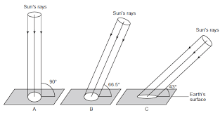
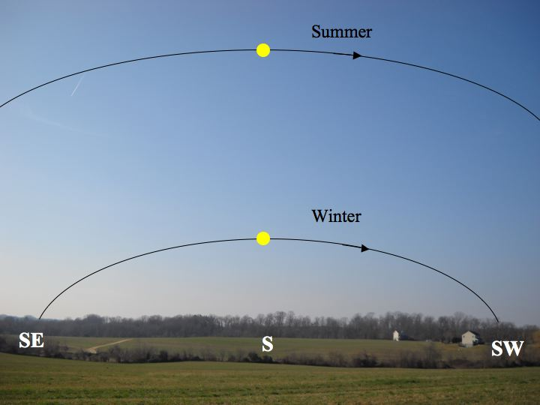
The following data table shows information regarding the suns angle of incidence (angle at which the sun strikes the surface relative to the horizon/flat ground), compass direction at various times of the day, and the duration of daylight/insolation in NYS.
Date  (First dates of summer, fall, winter, spring) | Angle of incidence (degrees) | Length of Day (hours) | Direction of sun from sunrise until solar noon | Direction of sun at solar noon | Direction of sun after solar noon to sunset
June 21 | 73.5 | 15 | Northeast | South | Northwest
Sept. 21 | 50 | 12 | East | South | West
Dec. 21 | 26.5 | 9 | Southeast | South | Southwest
March 21 | 50 | 12 | East | South | West

Part I: Reading and interpreting data
- How does the angle of incidence change from the beginning of summer until the first day of fall?

- Does this relationship change or remain the same we move from fall until the first day of winter?

- How does the angle of incidence change from the beginning of winter until the first day of summer?

- By how many degrees does the angle of incidence change from season to season?

- How does the length of day change from the first day of summer until the first day of winter?

- How does the length of day change from the first day of winter until the first day of summer?

- During which seasons do we experience equal hours of day and night?

Part II: Inference
- Based on the data listed above, state two reasons why a person is more likely to receive a sunburn during the summer months as compared to the winter months.

Part III. A shadow is always cast in the opposite direction that light is coming from. In this part of the lab, you will take seasonal data on shadow length and direction in relationship to the angle of insolation and direction of sun at the time of your experiment. Refer to the data table on page 1 when necessary.
*NOTE THAT THIS DATA TABLE WILL ONLY BE COMPLETE SOMETIME DURING QUARTER 4!
Today’s date and time | Direction the sun’s rays are coming from | Direction your shadow is cast | Shadow Length (m)

Analysis and Prediction (to be done after second date the data is collected)
- How does the shadow length change as the angle of insolation decreases?

- How will your shadow length change from winter to spring? And from spring to summer?

Conclusion Questions (to be done once data table is completed)
- State the relationship between the angle of insolation and shadow length

- On what date of the year could one expect the shortest shadow in NYS?

- If you were to do this same experiment during solar noon on the following dates, which direction would your shadow cast?
  - June 21-
  - Sept 21-
  - Dec 21-
  - March 21-

